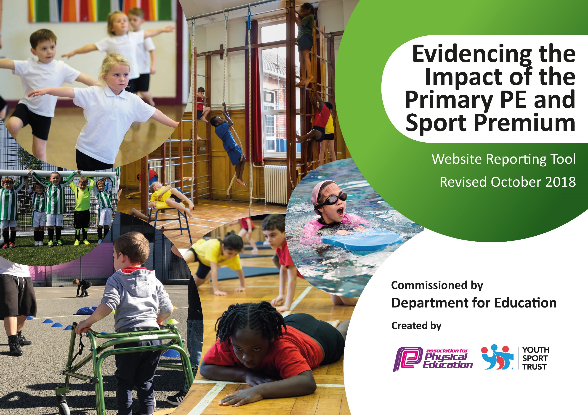
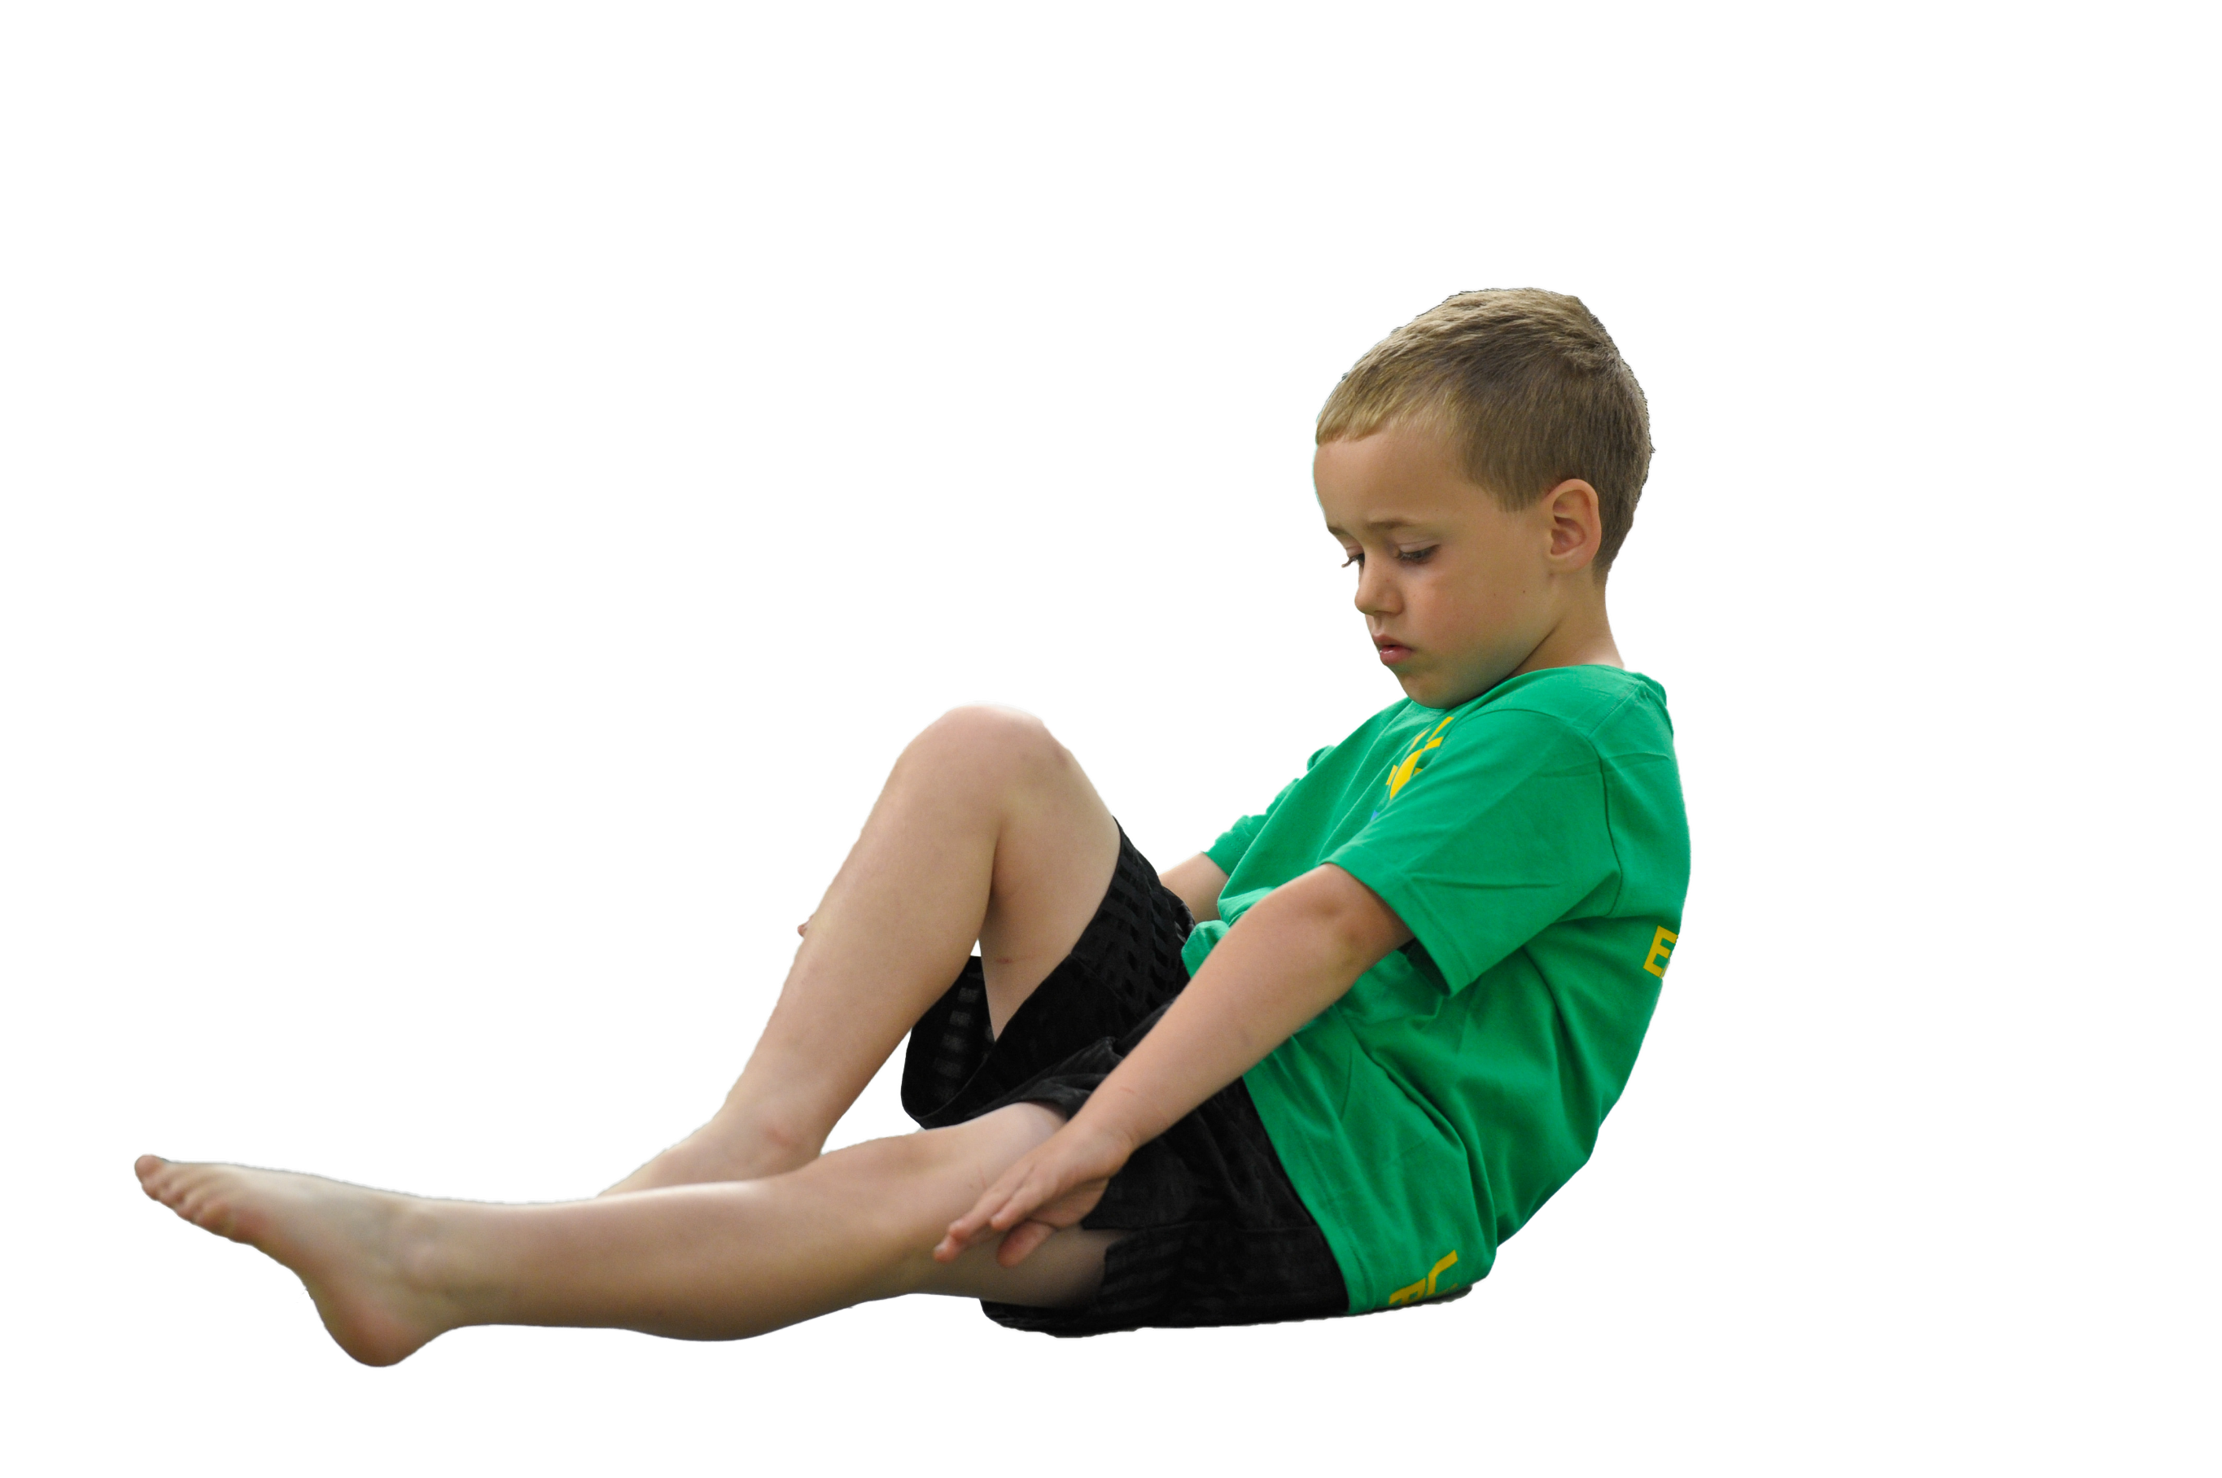
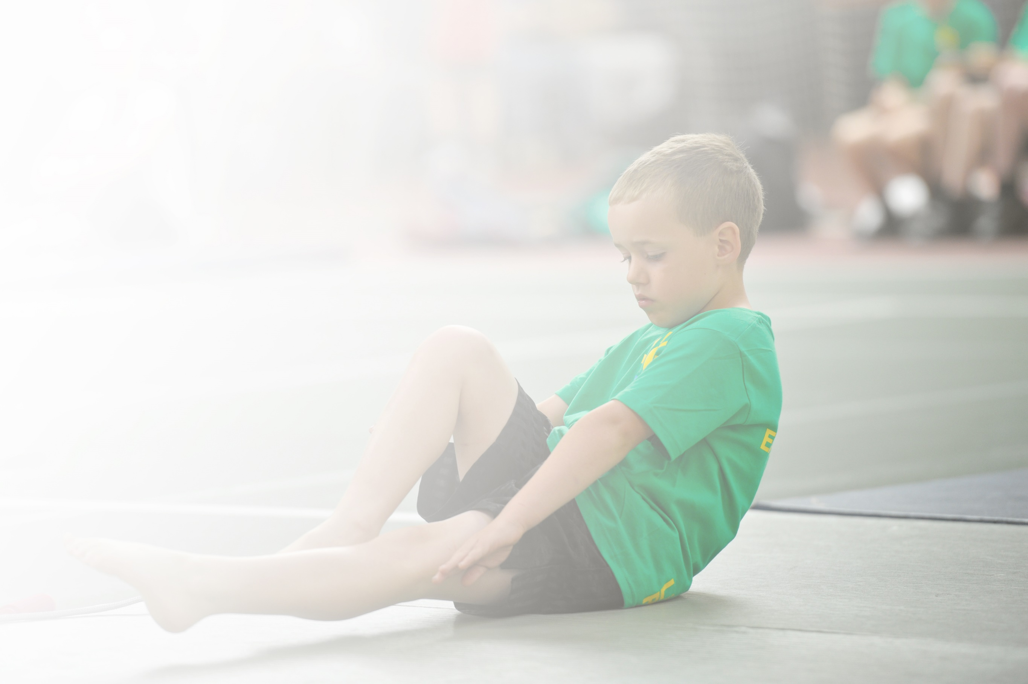
Schools must use the funding to make additional and sustainable improvements to the quality of Physical Education, Sport and Physical Activity (PESPA) they offer. This means that you should use the Primary PE and Sport Premium to:

- Develop or add to the PESPA activities that your school already offer
- Build capacity and capability within the school to ensure that improvements made now will benefit pupils joining the school in future years

Please visit gov.uk for the revised DfE guidance including the 5 key indicators across which schools should demonstrate an improvement. This document will help you to review your provision and to report
your spend. DfE encourages schools to use this template as an effective way of meeting the reporting requirements of the Primary PE and Sport Premium.

We recommend you start by reflecting on the impact of current provision and reviewing the previous
spend. Under the Ofsted Schools Inspection Framework, inspectors will assess how effectively leaders use the Primary PE and Sport Premium and measure its impact on outcomes for pupils, and how effectively governors hold them to account for this.

Schools are required to publish details of how they spend this funding as well as on the impact it has on pupils’ PE and sport participation and attainment by the end of the summer term or by 31 July 2019 at the
latest.
We recommend regularly updating the table and publishing it
on your website throughout the year, as evidence of your
ongoing review into how you are using the money to
secure maximum, sustainable impact. To see an
example of how to complete the table please
click HERE.

Support for review and reflection - considering the 5 key indicators from DfE, what development needs are a priority for your setting and your students now and why? Use the space below to reflect on previous spend, identify current need and priorities for the future.

Key achievements to date: | Areas for further improvement and baseline evidence of need:
Platinum School Games Award  Rotherham United partnership  Increase in activity levels of children.  Increased participation after school clubs  Increased participation out of school clubs  Increased participation in school competitions  #Fitin15  Year 6 led sports day  Increase in FS physical activity  Range of after school clubs. | Develop pathways for children outside of school  Upskill adults in provision of activity for children  Continue to make improvements to outdoor areas, to improve active opportunities  Increase pupil premium and SEN children in activities in and out of school  Develop influence and voice of sport council.

Meeting national curriculum requirements for swimming and water safety | Please complete all of the below:
What percentage of your current Year 6 cohort swim competently, confidently and proficiently over a distance of at least 25 metres?  N.B. Even though your children may swim in another year please report on their attainment on leaving  primary school. | 97%
What percentage of your current Year 6 cohort use a range of strokes effectively [for example, front crawl, backstroke and breaststroke]? | 94%
What percentage of your current Year 6 cohort perform safe self-rescue in different water-based situations? | 94%
Schools can choose to use the Primary PE and Sport Premium to provide additional provision for swimming but this must be for activity over and above the national curriculum requirements. Have you used it in this way? | No

Action Plan and Budget Tracking
Capture your intended annual spend against the 5 key indicators. Clarify the success criteria and evidence of impact that you intend to measure to evaluate for students today and for the future.

Academic Year: 2018/19 | Total fund allocated: £18,300 | Date Updated: 6/11/18
Key indicator 1: The engagement of all pupils in regular physical activity – Chief Medical Officer guidelines recommend that primary school children undertake at least 30 minutes of physical activity a day in school |  |  |  | Percentage of total allocation:
 |  |  |  | 24%
School focus with clarity on intended impact on pupils: | Actions to achieve: | Funding allocated: | Evidence and impact: | Sustainability and suggested next steps:
Improve outdoor provision in order to promote children to be more active.  Children to understand the importance of exercise. | More children being active at free times across all areas including during #Fitin15 sessions.  Develop motor control skills KS1.  Children will become self-aware of the amount of exercise needed as well as the importance of a healthy diet. | £400  £4032  See Rotherham United. | Break time resources to be purchased to allow a wider range of activities led and supported by adults to be implemented e.g. skipping ropes  KS1/KS2 trim trail to be purchased and fitted  Outside equipment for FS, KS1 and KS2.  Rotherham United Kinder programme to be run with upper KS2.  Rotherham United structured sessions with the children during wet dinner times.  School to re-apply for the healthy schools award.
Key indicator 2: The profile of PESSPA being raised across the school as a tool for whole school improvement |  |  |  | Percentage of total allocation:
 |  |  |  | 25%
School focus with clarity on intended impact on pupils: | Actions to achieve: | Funding allocated: | Evidence and impact: | Sustainability and suggested next steps:
Improve motivation of KS2 children with regards to exercise. | More children involved in physical activity.  Raise the awareness of the importance of exercise through pupil voice.  Children to develop leadership opportunities. | £4,450.  See playtime resources.  £150 | Rotherham United school services contract to work with children at lunch time on a rotational basis. Player visits to stimulate the children’s motivation and share experiences.  KS2 School sports council set up with two adults from school.  Children to blog on the school games website and share this throughout school and on social media.  Year 6 to plan and host events, including sports day.

Key indicator 3: Increased confidence, knowledge and skills of all staff in teaching PE and sport |  |  |  | Percentage of total allocation:
 |  |  |  | 40%
School focus with clarity on intended  impact on pupils: | Actions to achieve: | Funding  allocated: | Evidence and impact: | Sustainability and suggested  next steps:
Improve CPD of teachers in order to improve the teaching of P.E. in school. | Teachers to have a half term period with a P.E. specialist in order to develop their understanding of planning and delivering of P.E. lessons.  Staff to be encouraged to plan and run after school clubs with the support of a member of staff who is confident with the teaching of P.E. | £6500  £1050 | Dan Bennett employed for half a day a week to upskill NQTs and teachers in a different area of PE to those from previous cycles.  Staff have become engaged in after school clubs with most after school clubs having two adults running them.
Key indicator 4: Broader experience of a range of sports and activities offered to all pupils |  |  |  | Percentage of total allocation:
 |  |  |  | 3%
School focus with clarity on intended  impact on pupils: | Actions to achieve: | Funding  allocated: | Evidence and impact: | Sustainability and suggested  next steps:
Additional Achievements:  School to provide provision for children to become active during daily learning and after school. | Children will have the opportunity to access physical learning when possible.  After school clubs set up for a wide –range of activities.  Make use of the school grounds to provide a variety of opportunities. | £100  £200  £100 | Active phonics  KS1 Mat Ball club  KS1 + FS multi skills  KS2 Dance  KS2 hockey  KS2 football  Basketball  Indoor games  Fitness club  Purchase of equipment for physical work on school grounds e.g. tree planting programme for outdoor learning.
Key indicator 5: Increased participation in competitive sport |  |  |  | Percentage of total allocation:
 |  |  |  | 7%
School focus with clarity on intended  impact on pupils: | Actions to achieve: | Funding  allocated: | Evidence and impact: | Sustainability and suggested  next steps:
Children taking part of a wide range of sport both in and out of the school cluster. | School to have an inclusive attitude to choosing children for school teams. Funding allocated to allow kit/costumes to be purchased  Children to be given the opportunity to compete outside of the Wath area.  Children to be given opportunities to develop links with outside of school clubs. | £550.  £400  N.A.  N.A.  £250 | School to put a troupe into the Wath comprehensive movement evening event.  More than one team being taken to school games e.g. LKS2 football and KS1 Matball/ Hockey.  Whole Y2 and Y6 class taken to EIS for school Olympic day.  Y6 cricket day at Wath cricket club.  Insurance of staff vehicles and positive engagement of parents to allow children to attend competitions when they have won local events e.g. cross country finals.  School to develop positive links with clubs when we attend events (Wath cricket club, Rotherham Harriers).  School to use the knowledge of their P.E. specialist to provide information about local clubs if they show an interest in a particular sport.  Transport costs

