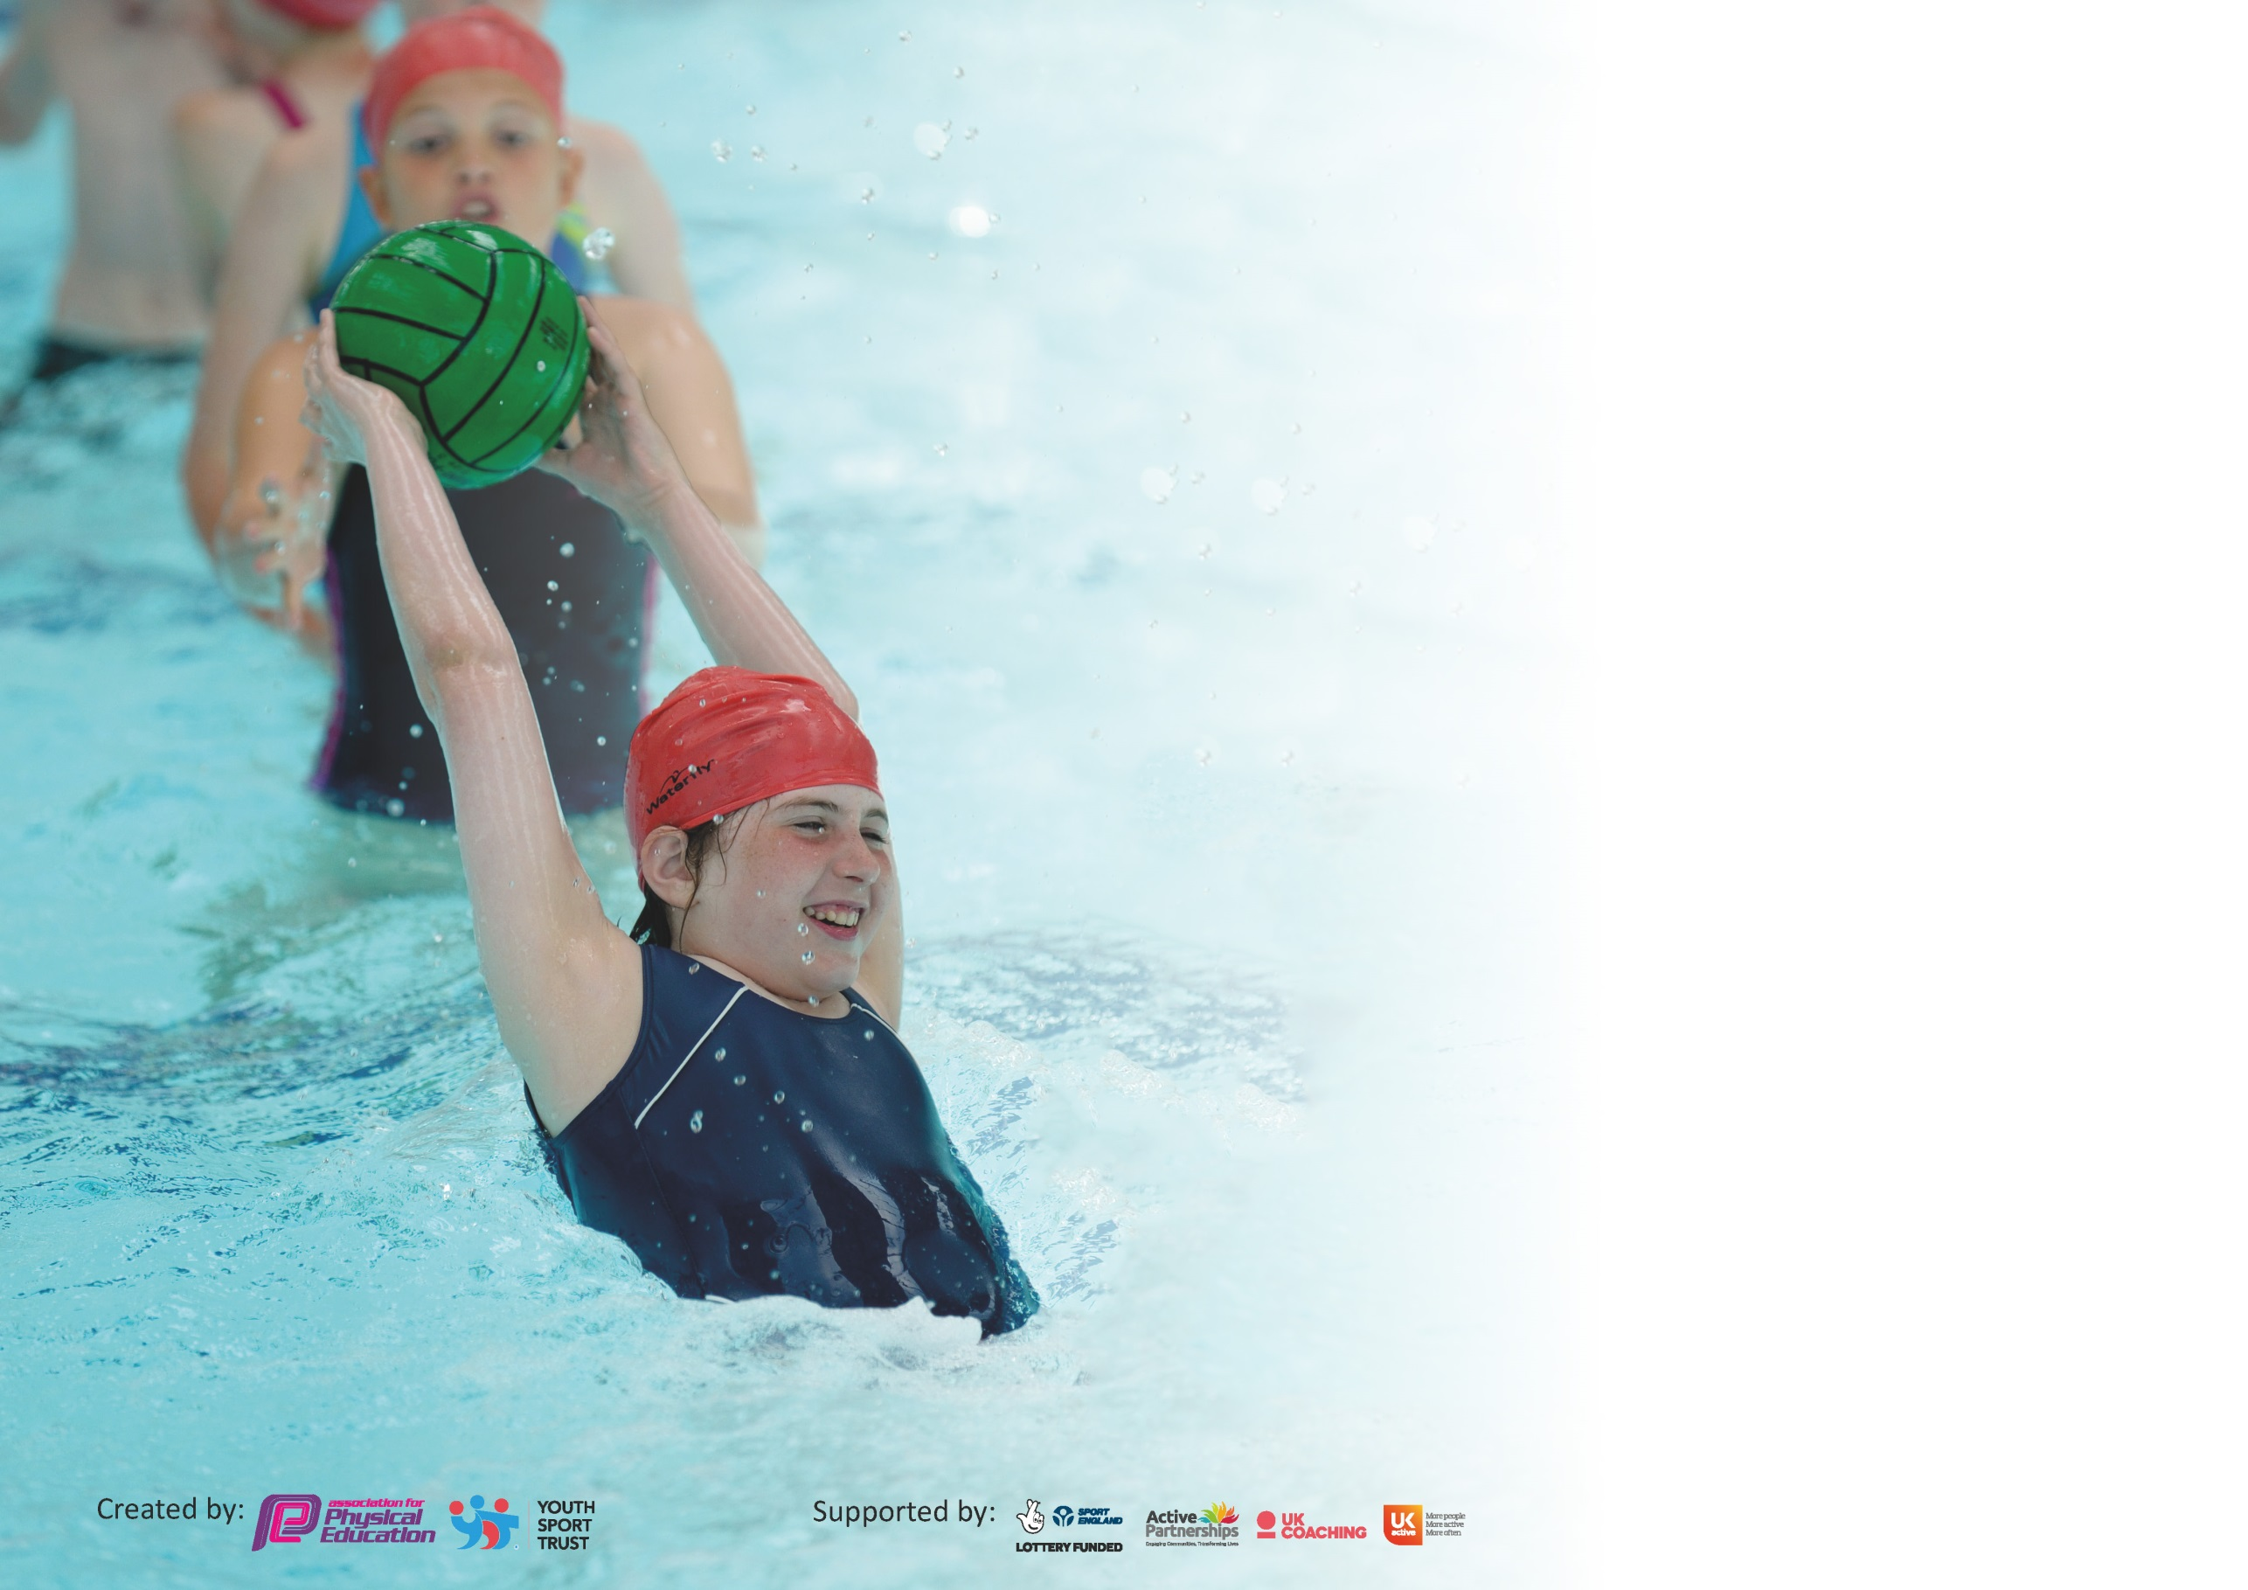

It is important that your grant is used effectively and based on school need. The Education Inspection Framework (Ofsted 2019 p64) makes clear there will be a focus on ‘whether leaders and those responsible for governors all understand their respective roles and perform these in a way that enhances the effectiveness of the school’.

Under the Quality of Education criteria (p41) inspectors consider the extent to which schools can articulate their curriculum (INTENT), construct their curriculum (IMPLEMENTATION) and demonstrate the outcomes which result (IMPACT).

To assist schools with common transferable language this template has been developed to utilise the same three headings which should make your plans easily transferable between working documents.

Schools must use the funding to make additional and sustainable improvements to the quality of Physical Education, School Sport and Physical Activity (PESSPA) they offer. This means that you should
use the Primary PE and Sport Premium to:

- Develop or add to the PESSPA activities that your school already offer
- Build capacity and capability within the school to ensure that improvements made now will benefit pupils joining the school in future years

Please visit gov.uk for the revised DfE guidance including the 5 key indicators across which schools should demonstrate an improvement. This document will help you to review your provision and to report your spend. DfE encourages schools to use this template as an effective way of meeting the reporting requirements of the Primary PE and Sport Premium.

We recommend you start by reflecting on the impact of current provision and reviewing the previous spend.

Schools are required to publish details of how they spend this funding as well as on the impact it has on pupils’ PE and sport participation and attainment by the end of the summer term or by 31st July 2020 at the latest.

We recommend regularly updating the table and publishing it on your website throughout the year. This evidences your ongoing self-evaluation of how you are using the funding to secure maximum, sustainable impact. Final copy must be posted on your website by the end of the academic year and no later than the 31st July 2020. To see an example of how to complete the table please click HERE.

Support for review and reflection - considering the 5 key indicators from DfE, what development needs are a priority for your setting and your pupils now and why? Use the space below to reflect on previous spend and key achievements and areas for development.

Key achievements to date until July 2019: | Areas for further improvement and baseline evidence of need:
Platinum School Games Award  Further increased participation after school clubs  Further increased participation out of school clubs  Further increased participation in school competitions  Further increase in activity levels of children, shown through active playtimes, #fitin15, PE.  Increased participation in #Fitin15  Further developed #Fitin15 activities  Year 6 led sports day  Employment of sports coach to promote health and fitness, throughout school  Increasing range of after school clubs.  School achieve both the bronze and silver healthy schools award | To continue to develop pathways for children outside of school  Upskill new adults in provision of activity for children  Continue to make improvements to outdoor areas, to improve active opportunities  Increase pupil premium and SEN children in activities in and out of school  Develop influence and voice of sport council.  To be successful in retaining the Platinum School Games Award.

Meeting national curriculum requirements for swimming and water safety.
What percentage of your current Year 6 cohort swim competently, confidently and proficiently over a distance of at least 25 metres?  N.B. Even though your pupils may swim in another year please report on their attainment on leaving  primary school at the end of the summer term 2020. | 98%
What percentage of your current Year 6 cohort use a range of strokes effectively [for example, front crawl, backstroke and breaststroke]? | 93%
What percentage of your current Year 6 cohort perform safe self-rescue in different water-based situations? | 95%
Schools can choose to use the Primary PE and Sport Premium to provide additional provision for swimming but this must be for activity over and above the national curriculum requirements. Have you used it in this way? | No

Action Plan and Budget Tracking
Capture your intended annual spend against the 5 key indicators. Clarify the success criteria and evidence of impact that you intend to measure to evaluate for pupils today and for the future.

Academic Year: 2019/2020 | Total fund allocated: £18,300 | Date Updated:1.7.20
Key indicator 1: The engagement of all pupils in regular physical activity – Chief Medical Officer guidelines recommend that primary school pupils undertake at least 30 minutes of physical activity a day in school |  |  |  | Percentage of total allocation:
 |  |  |  | 2.2%
Intent | Implementation |  | Impact
Your school focus should be clear what you want the pupils to know and be able to do and about  what they need to learn and to  consolidate through practice: | Make sure your actions to achieve are linked to your intentions: | Funding allocated: | Evidence of impact: what do pupils now know and what can they now do? What has changed?: | Sustainability and suggested next steps:  Reviewed July 2020.
Improve outdoor provision in order to promote children to be more active at free times across all areas including during #Fitin15 sessions.  Children will become self-aware of the amount of exercise needed as well as the importance of a healthy diet. | Break time resources to be purchased to allow a wider range of activities led and supported by adults to be implemented e.g. skipping ropes  Sports coach to provide structured sessions with the children during wet dinner times.  School to re-apply for the gold healthy schools award. | £400  See Sports Coach | All children take part in active playtimes and dinner times.  All children in KS1 and KS2 were able to take part in sport provision at lunchtimes on rota.  #fitin15, PSHE and PE lessons reinforce messages about healthy active behaviours.  Healthy school award application submitted. Awaiting possible confirmation of award. | Led by the sports coach, children will engage in a wider range of activities to try and encourage increased participation in after school clubs both in and out of school.  Importance of health and exercise to be re-visited in PSHE lessons. No needed as a target on 2020-2021 plan.
Key indicator 2: The profile of PESSPA being raised across the school as a tool for whole school improvement |  |  |  | Percentage of total allocation:
 |  |  |  | 47.3%
Intent | Implementation |  | Impact
Your school focus should be clear what you want the pupils to know and be able to do and about  what they need to learn and to  consolidate through practice: | Make sure your actions to achieve are linked to your intentions: | Funding allocated: | Evidence of impact: what do pupils now know and what can they now do? What has changed?: | Sustainability and suggested next steps:
Increase the amount of children involved in physical activity.  Raise the awareness of the importance of exercise through pupil voice.  Children to develop leadership opportunities. | Sport Coach to work with children at lunchtime on a rotational basis.  KS2 School sports council set up with two adults from school.  Year 6 to plan and host events, including sports day. | £8,500  See playtime resources.  £150 | Children in KS1 and KS2 are being actively engaged at dinner times with Sport Coach with most(70-80%)children taking part in activity at play times . Sport Coach aided children who took part in competitions and helped further promote an active lifestyle to both children and adults.  Sport Council to be set up, which will include children from across the school (2 per year group). These children will aid promoting health and fitness across school.  Children to blog on the school games website and share this throughout school and on social media.  Sports day did not take place due to COVID. | Sport coach to attend CPD to further his own skills. Sport coach to provide CPD to staff members to improve provision.  Sport council to be re-nominated. Regular meetings will provide children with the opportunity to voice their opinions.  Sports day was not possible due to COVID-19 .  Target continued to 2020-2021.Look at how this can be implemented into other year groups.

Key indicator 3: Increased confidence, knowledge and skills of all staff in teaching PE and sport |  |  |  | Percentage of total allocation:
 |  |  |  | 41.7%
Intent | Implementation |  | Impact
Your school focus should be clear | Make sure your actions to | Funding | Evidence of impact: what do | Sustainability and suggested
what you want the pupils to know | achieve are linked to your | allocated: | pupils now know and what | next steps:
and be able to do and about | intentions: |  | can they now do? What has
what they need to learn and to |  |  | changed?:
consolidate through practice:
Improve CPD of teachers in order to improve the teaching of P.E. in school.  Staff to be encouraged to plan and run after school clubs with the support of a member of staff who is confident with the teaching of P.E. | Teachers to have a half term period with a P.E. specialist in order to develop their understanding of planning and delivering of P.E. lessons.  Dan Bennett employed for half a day a week to upskill all teachers in an identified area of weakness area of PE. DB has supported staff members with the teaching of Dance. DB to be observed teaching, then both DB and staff member to teach, before staff member teaches with DB observing.  Staff to run a wide range of after school clubs to provide different after school clubs. At least 2 after school clubs provided per night (Mon-Thurs) and these change every half term. | £6500  £1150 | Teachers has increased in confidence in their self-diagnosed weakest area of teaching. 100% of teachers took part in CPD.  56% of the school engaged in after school clubs. | Process to continue with the immediate focus of improving the practice of NQTs.  Aim to have 62% of the school involved in after school clubs. Conduct pupil voice with target groups of children to see what can be offered. Aim for after school clubs to be up and running after October 2020.
Key indicator 4: Broader experience of a range of sports and activities offered to all pupils |  |  |  | Percentage of total allocation:
 |  |  |  | 2.2%
Intent | Implementation |  | Impact
Your school focus should be clear | Make sure your actions to | Funding | Evidence of impact: what do | Sustainability and suggested
what you want the pupils to know | achieve are linked to your | allocated: | pupils now know and what | next steps:
and be able to do and about | intentions: |  | can they now do? What has
what they need to learn and to |  |  | changed?:
consolidate through practice:
Children will have the opportunity to access physical learning when possible.  Give children to opportunity to access a wide-range of sporting activities.  Make use of the school grounds to provide a variety of opportunities. | Active phonics  After school clubs set up for a wide –range of activities.  KS1 Football  KS1 + FS multi skills  KS2 Dance  KS2 hockey  KS2 football  KS2 gymnastics  KS1 and 2 Basketball  Indoor games  Fitness club  Purchase of equipment for physical work on school grounds | £50  £250  £100 | Children have increased engagement and participation in phonics, which has aided progress.  Increased uptake in after school clubs across all year groups.  Further ground work has taken place to ensure the ground is suitable for games. More of the school grounds are now accessible and suitable for sport. | How can physical learning be included into other subject areas?  CPD opportunities to be investigated for key staff to provide quality provision of other sports.  General upkeep and maintenance needed on the school site.

Key indicator 5: Increased participation in competitive sport |  |  |  | Percentage of total allocation:
 |  |  |  | 6.6%
Intent | Implementation |  | Impact
Your school focus should be clear | Make sure your actions to | Funding | Evidence of impact: what do | Sustainability and suggested
what you want the pupils to know | achieve are linked to your | allocated: | pupils now know and what | next steps:
and be able to do and about | intentions: |  | can they now do? What has
what they need to learn and to |  |  | changed?:
consolidate through practice:
School to have an inclusive attitude to choosing children for school teams. Funding allocated to allow kit/costumes to be purchased  Celebrate achievement and promote opportunities out of school. | School to put a troupe into the Wath comprehensive movement evening event. 2 or 3 teams to be taken to variety of school games and competitions. School provided a free taster session for pound rockout group. Whole Y2 and Y6 class taken to EIS for school Olympic day.  Y6 cricket day at Wath cricket club.  Children allowed to share achievements in school assemblies. Monthly challenges set for children and recognised in school. School to develop positive links with clubs when we attend events. School to, where possible, attend events run by outside agencies. School to help with transport and insurance costs.  Wath RUFC invited in to so rugby taster sessions. | £950  £250 | School dance team received quality teaching for the cluster dance competition. Pound rockout after school club reached maximum capacity. EIS and Y6 Cricket did not happen due to COVID.  Success in school cross country in which 3 children were invited to join the Rotherham Harriers running team. Monthly challenges have had a mixed response dependent on the theme. Wath RUFC sessions did not happen due to COVID. | School to re-employ dance teacher next year and to increase the amount of taster sessions and publicity given to after school clubs.  School to continue to try to access as many out of school opportunities as possible. School to invite groups in for taster sessions to try and improve profile in the community.

Signed off by
Head Teacher: | C Miller
Date: | 17.7.20
Subject Leader: | Thomas Kaskiewicz
Date: | 17.7.20
Governor: | J Charlesworth
Date: | 17.7.20

