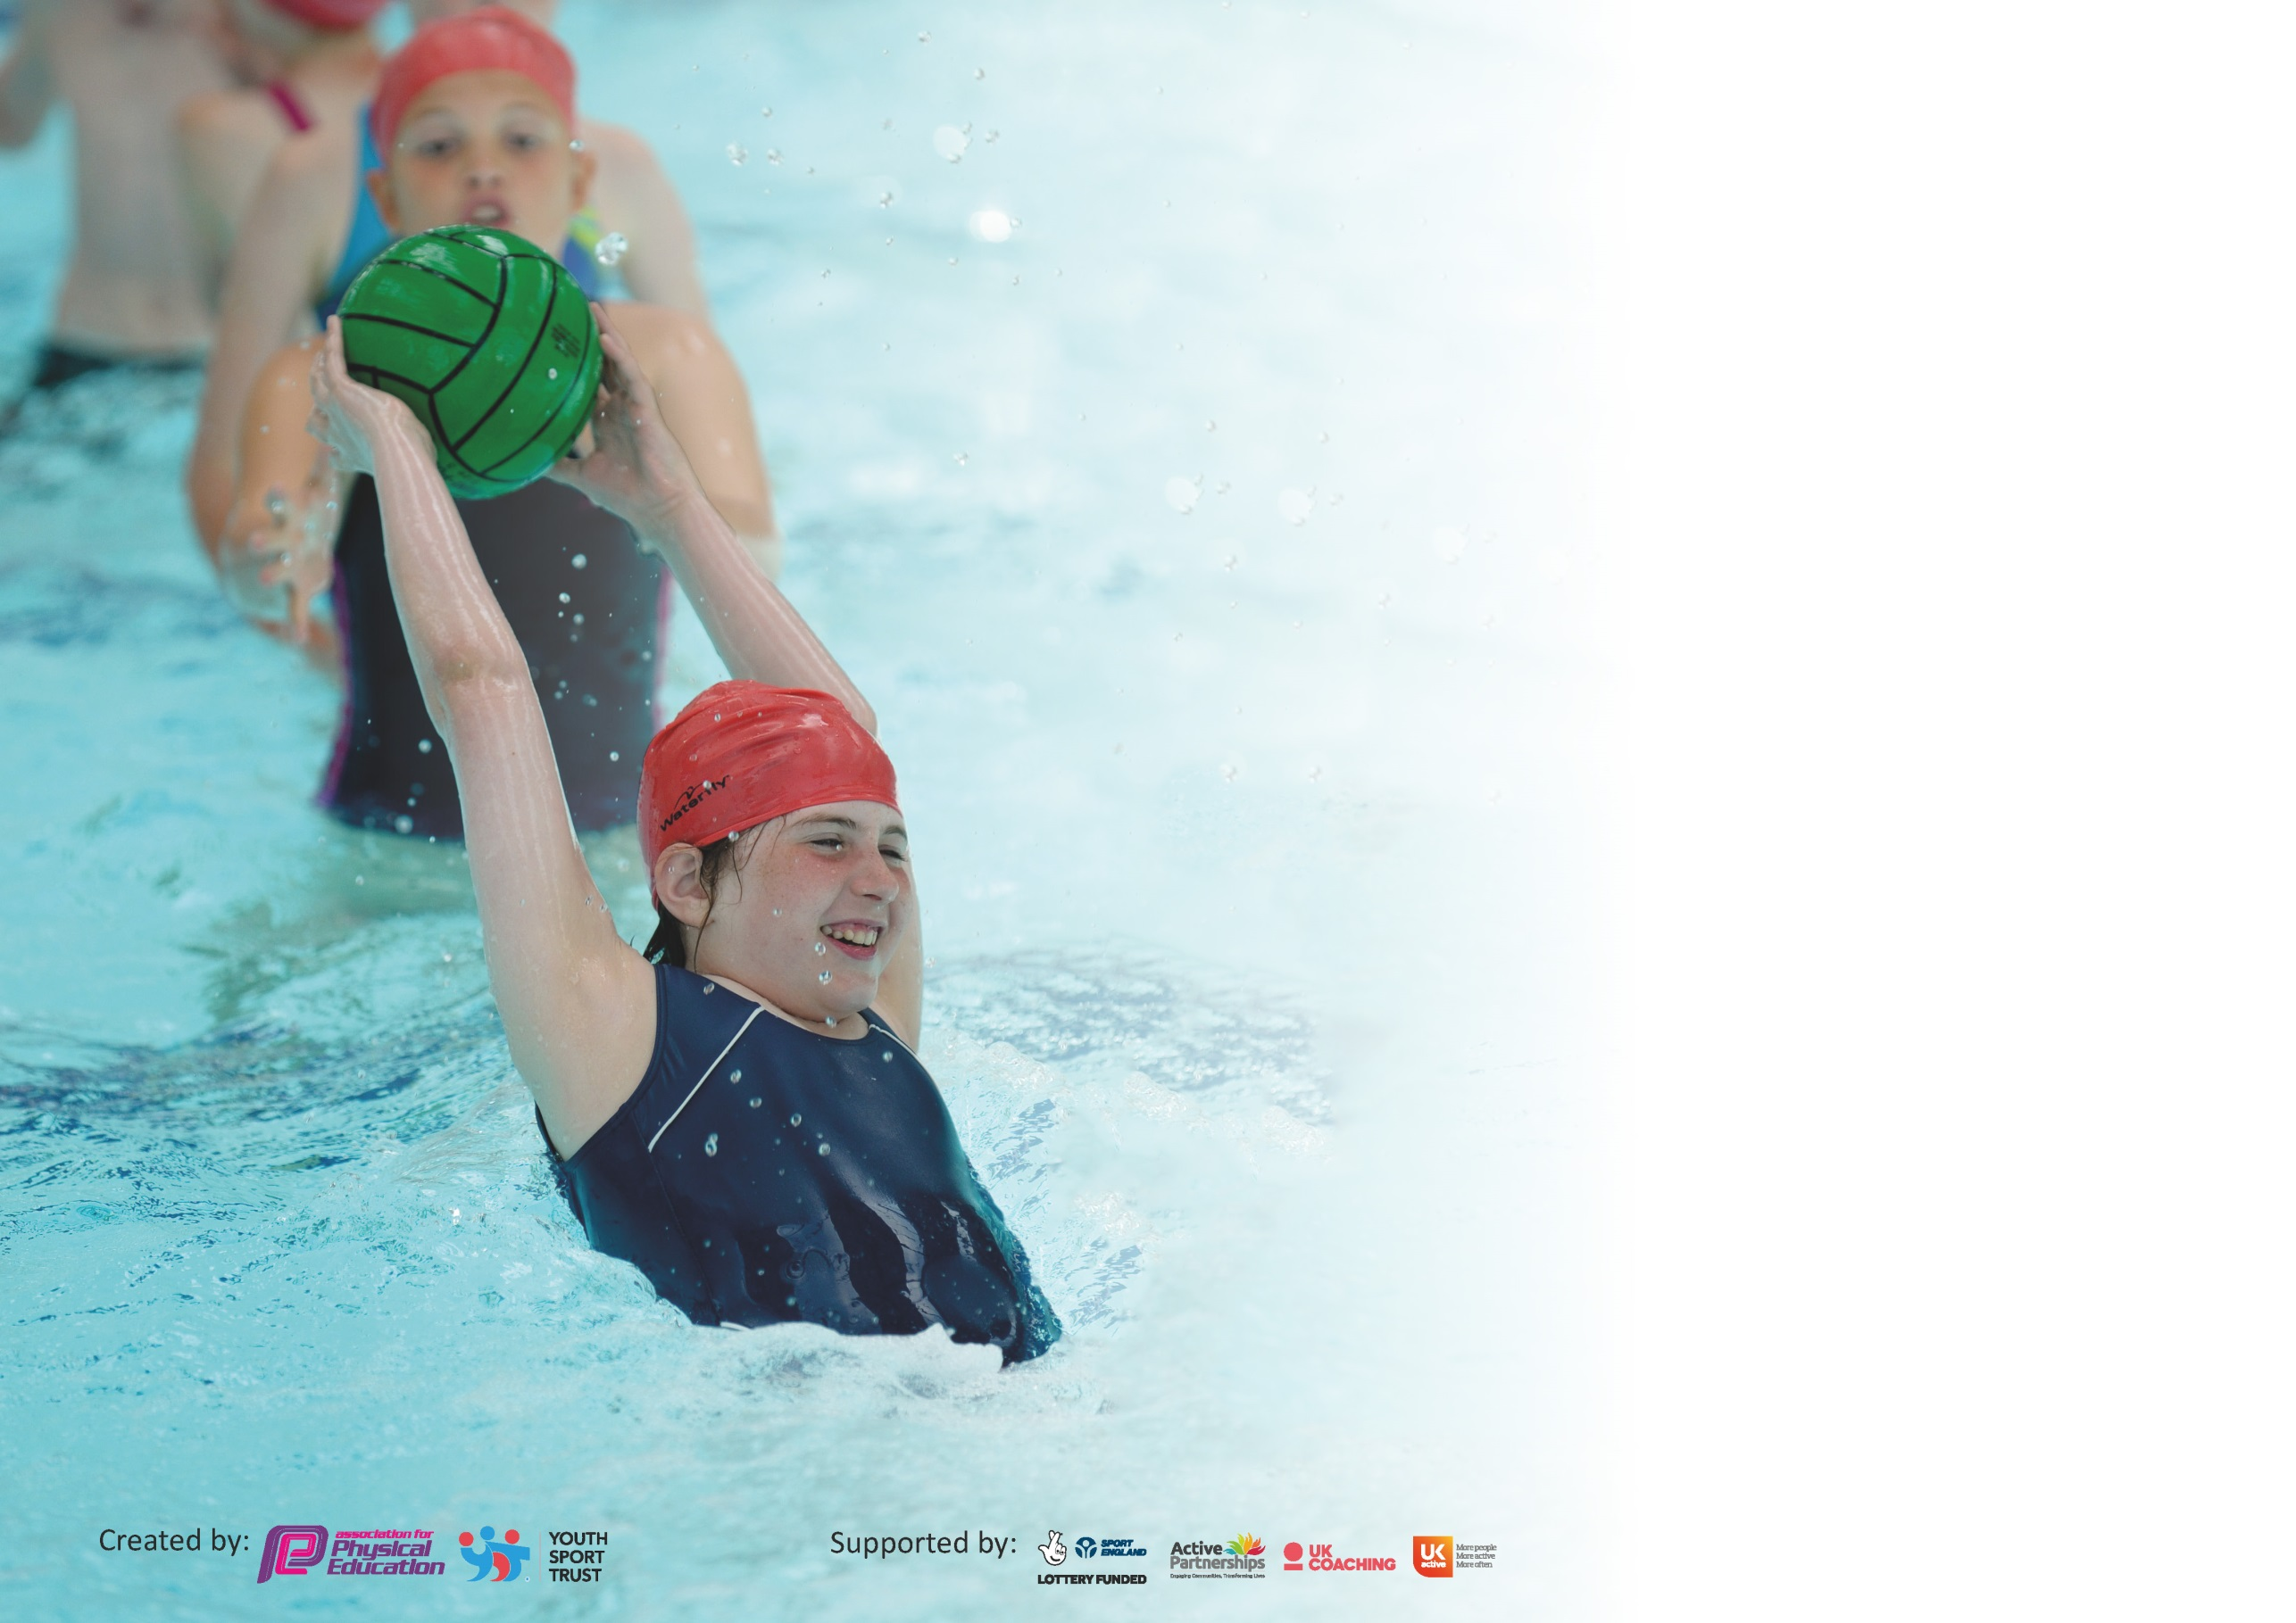

It is important that your grant is used effectively and based on school need. The Education Inspection Framework (Ofsted 2019 p64) makes clear there will be a focus on ‘whether leaders and those responsible for governors all understand their respective roles and perform these in a way that enhances the effectiveness of the school’.

Under the Quality of Education criteria (p41) inspectors consider the extent to which schools can articulate their curriculum (INTENT), construct their curriculum (IMPLEMENTATION) and demonstrate the outcomes which result (IMPACT).

To assist schools with common transferable language this template has been developed to utilise the same three headings which should make your plans easily transferable between working documents.

Schools must use the funding to make additional and sustainable improvements to the quality of Physical Education, School Sport and Physical Activity (PESSPA) they offer. This means that you should
use the Primary PE and Sport Premium to:

- Develop or add to the PESSPA activities that your school already offer
- Build capacity and capability within the school to ensure that improvements made now will benefit pupils joining the school in future years

Please visit gov.uk for the revised DfE guidance including the 5 key indicators across which schools should demonstrate an improvement. This document will help you to review your provision and to report your spend. DfE encourages schools to use this template as an effective way of meeting the reporting requirements of the Primary PE and Sport Premium.

We recommend you start by reflecting on the impact of current provision and reviewing the previous spend.

Schools are required to publish details of how they spend this funding as well as on the impact it has on pupils’ PE and sport participation and attainment by the end of the summer term or by 31st July 2020 at the latest.

We recommend regularly updating the table and publishing it on your website throughout the year. This evidences your ongoing self-evaluation of how you are using the funding to secure maximum, sustainable impact. Final copy must be posted on your website by the end of the academic year and no later than the 31st July 2020. To see an example of how to complete the table please click HERE.

Support for review and reflection - considering the 5 key indicators from DfE, what development needs are a priority for your setting and your pupils now and why? Use the space below to reflect on previous spend and key achievements and areas for development.

Key achievements to date until July 2019: | Areas for further improvement and baseline evidence of need:
Platinum School Games Award  Further increased participation after school clubs  Further increased participation out of school clubs  Further increased participation in school competitions  Further increase in activity levels of children, shown through active playtimes, #fitin15, PE.  Increased participation in #Fitin15  Further developed #Fitin15 activities  Year 6 led sports day  Employment of sports coach to promote health and fitness, throughout school  Increasing range of after school clubs.  School achieve both the bronze and silver healthy schools award | To continue to develop pathways for children outside of school  Upskill new adults in provision of activity for children  Continue to make improvements to outdoor areas, to improve active opportunities  Increase pupil premium and SEN children in activities in and out of school  Develop influence and voice of sport council.  To be successful in retaining the Platinum School Games Award.

Meeting national curriculum requirements for swimming and water safety.
What percentage of your current Year 6 cohort swim competently, confidently and proficiently over a distance of at least 25 metres?  N.B. Even though your pupils may swim in another year please report on their attainment on leaving  primary school at the end of the summer term 2020. | 98%
What percentage of your current Year 6 cohort use a range of strokes effectively [for example, front crawl, backstroke and breaststroke]? | 93%
What percentage of your current Year 6 cohort perform safe self-rescue in different water-based situations? | 95%
Schools can choose to use the Primary PE and Sport Premium to provide additional provision for swimming but this must be for activity over and above the national curriculum requirements. Have you used it in this way? | No

Action Plan and Budget Tracking
Capture your intended annual spend against the 5 key indicators. Clarify the success criteria and evidence of impact that you intend to measure to evaluate for pupils today and for the future.

Academic Year: 2018/19 | Total fund allocated: £ | Date Updated:
Key indicator 1: The engagement of all pupils in regular physical activity – Chief Medical Officer guidelines recommend that primary school pupils undertake at least 30 minutes of physical activity a day in school |  |  |  | Percentage of total allocation:
 |  |  |  | 2.2%
Intent | Implementation |  | Impact
Your school focus should be clear what you want the pupils to know and be able to do and about  what they need to learn and to  consolidate through practice: | Make sure your actions to achieve are linked to your intentions: | Funding allocated: | Evidence of impact: what do pupils now know and what can they now do? What has changed?: | Sustainability and suggested next steps:
Improve outdoor provision in order to promote children to be more active.  Children to understand the importance of exercise. | More children being active at free times across all areas including during #Fitin15 sessions.  Children will become self-aware of the amount of exercise needed as well as the importance of a healthy diet. | £400  See Sports Coach | Break time resources to be purchased to allow a wider range of activities led and supported by adults to be implemented e.g. skipping ropes  Sports coach to provide structured sessions with the children during wet dinner times.  School to re-apply for the gold healthy schools award.
Key indicator 2: The profile of PESSPA being raised across the school as a tool for whole school improvement |  |  |  | Percentage of total allocation:
 |  |  |  | 47.3%
Intent | Implementation |  | Impact
Your school focus should be clear what you want the pupils to know and be able to do and about  what they need to learn and to  consolidate through practice: | Make sure your actions to achieve are linked to your intentions: | Funding allocated: | Evidence of impact: what do pupils now know and what can they now do? What has changed?: | Sustainability and suggested next steps:
Improve motivation of KS2 children with regards to exercise. | More children involved in physical activity.  Raise the awareness of the importance of exercise through pupil voice.  Children to develop leadership opportunities. | £8,500  See playtime resources.  £150 | Sport Coach to work with children at lunchtime on a rotational basis. Player visits to stimulate the children’s motivation and share experiences.  KS2 School sports council set up with two adults from school.  Children to blog on the school games website and share this throughout school and on social media.  Year 6 to plan and host events, including sports day.

Key indicator 3: Increased confidence, knowledge and skills of all staff in teaching PE and sport |  |  |  | Percentage of total allocation:
 |  |  |  | 41.7%
Intent | Implementation |  | Impact
Your school focus should be clear | Make sure your actions to | Funding | Evidence of impact: what do | Sustainability and suggested
what you want the pupils to know | achieve are linked to your | allocated: | pupils now know and what | next steps:
and be able to do and about | intentions: |  | can they now do? What has
what they need to learn and to |  |  | changed?:
consolidate through practice:
Improve CPD of teachers in order to improve the teaching of P.E. in school. | Teachers to have a half term period with a P.E. specialist in order to develop their understanding of planning and delivering of P.E. lessons.  Staff to be encouraged to plan and run after school clubs with the support of a member of staff who is confident with the teaching of P.E. | £6500  £1150 | Dan Bennett employed for half a day a week to upskill all teachers in an identified area of weakness area of PE.  Staff have become engaged in after school clubs with most after school clubs having two adults running them.
Key indicator 4: Broader experience of a range of sports and activities offered to all pupils |  |  |  | Percentage of total allocation:
 |  |  |  | 2.2%
Intent | Implementation |  | Impact
Your school focus should be clear | Make sure your actions to | Funding | Evidence of impact: what do | Sustainability and suggested
what you want the pupils to know | achieve are linked to your | allocated: | pupils now know and what | next steps:
and be able to do and about | intentions: |  | can they now do? What has
what they need to learn and to |  |  | changed?:
consolidate through practice:
Additional Achievements:  School to provide provision for children to become active during daily learning and after school. | Children will have the opportunity to access physical learning when possible.  After school clubs set up for a wide –range of activities.  Make use of the school grounds to provide a variety of opportunities. | £50  £250  £100 | Active phonics  KS1 Football  KS1 + FS multi skills  KS2 Dance  KS2 hockey  KS2 football  KS2 gymnastics  KS1 and 2 Basketball  Indoor games  Fitness club  Purchase of equipment for physical work on school grounds

Key indicator 5: Increased participation in competitive sport |  |  |  | Percentage of total allocation:
 |  |  |  | 6.6%
Intent | Implementation |  | Impact
Your school focus should be clear | Make sure your actions to | Funding | Evidence of impact: what do | Sustainability and suggested
what you want the pupils to know | achieve are linked to your | allocated: | pupils now know and what | next steps:
and be able to do and about | intentions: |  | can they now do? What has
what they need to learn and to |  |  | changed?:
consolidate through practice:
Children taking part of a wide range of sport both in and out of the school cluster. | School to have an inclusive attitude to choosing children for school teams. Funding allocated to allow kit/costumes to be purchased  Children to be given the opportunity to compete outside of the Wath area.  Children to be given opportunities to develop links with outside of school clubs. | £500  £450  N.A.  N.A.  £250 | School to put a troupe into the Wath comprehensive movement evening event.  2 or 3 teams to be taken to variety of school games and competitions  Whole Y2 and Y6 class taken to EIS for school Olympic day.  Y6 cricket day at Wath cricket club.  Insurance of staff vehicles and positive engagement of parents to allow children to attend competitions when they have won local events.  School to develop positive links with clubs when we attend events.  School to links with local clubs if they show an interest in a particular sport.  Transport costs | School took a dancing troupe to Wath Comprehensive to compete in the movement evening.  Wide variety of children have volunteered and participated in school competitions. Wider range of children now partake in after school clubs. School to further develop links with more out of school clubs to encourage pathways.  Children, staff and parents allowed children to attend finals.  School has further developed links with Wath CC and other out of school clubs.

Signed off by
Head Teacher:
Date:
Subject Leader: | Thomas Kaskiewicz
Date:
Governor:
Date:

