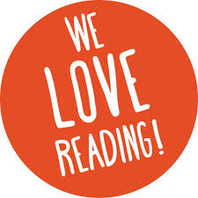
Reading For Pleasure
Home Learning Challenge

Here at Wath Victoria, we love reading and listening to all kinds of stories.
If you have finished the reading book you brought home from school, why not choose a new one to listen to from the Audible library? Children can listen to a huge range of fantastic stories for FREE at the moment, so it’s well worth taking some time and exploring the amazing range of stories on there. Remember to ask an adult to help you get online and pick a book from the correct age–range.
https://stories.audible.com/start-listen

Once you have finished listening to your story, you could:
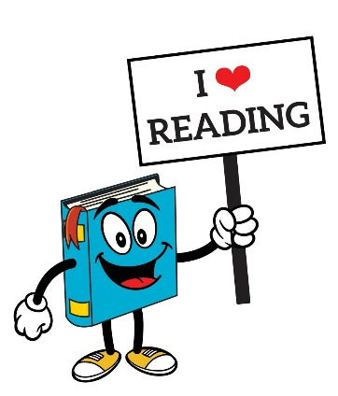
- Draw or paint a picture of the characters
- Draw a detailed sketch of the setting and label it with ideas from the story
- Write the next part of the story
- Write a diary entry for a character
- Invent a new character for the story and decide what it looks like and what its personality is like
- Write a book review about the story, telling your classmates why you think they would enjoy the story too.

Listening to stories is a fabulous way of inspiring you to keep reading and to make up your own stories too. We hope that you find a book which you love on the website. Don’t forget, you can always share your pictures or writing with your teachers on dojo or on your class email, if you like. Happy reading, everybody!

#teamwv

